SFC NETWORK MEMBERSHIP APPLICATION CHECKLIST
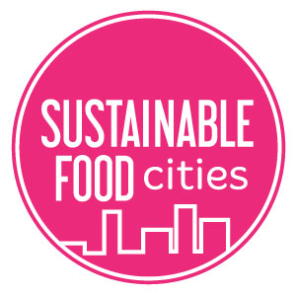
Item | Included
- Named lead person for your food partnership. This will be the main contact between SFC and your food partnership.
- Terms of reference document – this should include:

  - Name of your food partnership
  - List of stakeholders (name the organisation or public sector department). This must include representatives from public and third sectors; and from private sectors if possible. Note: If there are no private sector representatives then your action plan will need to clearly show how you intend to engage them.
  - Outline of your vision (could be bullet point list or summary paragraph). Note: It needs to be clear that you intend to work across all 6 key areas of SFC.
  - Decision making process for appointment of food partnership chair.
- Minutes from last 2 partnership meetings (these are used to evidence that you have a cross sectoral partnership that is actively meeting).
- Copy of your action plan

  - Must cover period of next 12 months
  - This can be in draft form if you are still consulting on it.

